**Assignment-based Subjective Questions**

1) From your analysis of the categorical variables from the dataset, what could you infer about their effect on the dependent variable?

There were 6 categorical variables in the dataset. (season, weathersit, mnth, holiday, weekday, workingday)

The inference that We could derive were:

season:

Almost 32% of the bike booking were happening in season3 with a median of over 5000 booking (for the period of 2 years). This was followed by season2 & season4 with 27% & 25% of total booking. This indicates, season can be a good predictor for the dependent variable.

mnth:

Almost 10% of the bike booking were happening in the months 5,6,7,8 & 9 with a median of over 4000 booking per month. This indicates, mnth has some trend for bookings and can be a good predictor for the dependent variable.

weathersit:

Almost 67% of the bike booking were happening during 'weathersitl with a median of close to 5000 booking (for the period of 2 years). This was followed by weathersit2 with 30% of total booking. This indicates, weathersit does show some trend towards the bike bookings can be a good predictor for the dependent variable.

holiday:

Almost 97.6% of the bike booking were happening when it is not a holiday which means this data is clearly biased. This indicates, holiday CANNOT be a good predictor for the dependent variable.

weekday:

weekday variable shows very close trend (between 13.5%-14.8% of total booking on all days of the week) having their independent medians between 4000 to 5000 bookings. This variable can have some or no influence towards the predictor. I will let the model decide if this needs to be added or not.

workingday:

Almost 69% of the bike booking were happening in 'workingday' with a median of close to 5000 booking (for the period of 2 years). This indicates, workingday can be a good predictor for the dependent variable

2) Why is it important to use drop_first=True during dummy variable creation?

Ans - drop_first=True is important to use, as it helps in reducing the extra column created during dummy variable creation. Hence it reduces the correlations created among dummy variables.

Let's say we have 3 types of values in Categorical column and we want to create dummy variable for that column. If one variable is not furnished and semi furnished, then It is obvious unfurnished. So, we do not need 3rd variable to identify the unfurnished. Hence if we have categorical variable with n-levels, then we need to use n-l columns to represent the dummy variables.

3 ) Looking at the pair-plot among the numerical variables, which one has the highest correlation with the target variable?

Ans -There is linear relationship between temp and atemp. Both of the parameters cannot be used in the model due to multicolinearity. We will decide which parameters to keep based on VIF and p-value w.r.t other variables

4 ) How did you validate the assumptions of Linear Regression after building the model on the training set?

VERY LOW Multicollinearity between the predictors and the p-values for all the predictors seems to be significant. For now, we will consider this as our final model (unless the Test data metrics are not significantly close to this number).

The Coefficient values from the model of all the variables are not equal to zero which

means we are able to reject Null Hypothesis F-Statistics is used for testing the overall significance of the Model: Higher the F-Statistics, more significant the Model is.

F-statistic: 233.8

Prob (F-statistic): 3.77+181

The F-Statistics value of 233 (which is greater than 1) and the p-value of 'NO.OOOO' states that the overall model is significant. The Residuals were normally distributed after plotting the histogram. Hence our assumption for Linear Regression is valid VIF calculation we could find that there is no multicollinearity existing between the predictor variables, as all the values are within permissible range of below 5.

5 ) Based on the final model, which are the top 3 features contributing significantly towards explaining the demand of the shared bikes?

As per our final Model, the top 3 predictor variables that influences the bike booking are:

Temperature (temp) - A coefficient value of '0.5636' indicated that a unit increase in temp variable increases the bike hire numbers by 0.5636 units.

Weather Situation 3 (weathersit_3) - A coefficient value of '-0.3070' indicated that, w.r.t

Weathersitl, a unit increase in Weathersit3 variable decreases the bike hire numbers by 0.3070 units.

Year (yr) - A coefficient value of '0.2308' indicated that a unit increase in yr variable increases the bike hire numbers by 0.2308 units.

So, it's suggested to consider these variables utmost importance while planning, to achieve maximum Booking

The next best features that can also be considered are

season 4: - A coefficient value of '0.128744' indicated that w.r.t season 1, a unit increase in season_4 variable increases the bike hire numbers by 0.128744 units.

windspeed: - A coefficient value of '-0.155191' indicated that, a unit increase in windspeed variable decreases the bike hire numbers by 0.155191 units.

General Subjective Questions

1. Explain the linear regression algorithm in detail.

Linear regression is a supervised machine learning method that is used by the [Train Using AutoML](https://pro.arcgis.com/en/pro-app/3.1/tool-reference/geoai/train-using-automl.htm) tool and finds a linear equation that best describes the correlation of the explanatory variables with the dependent variable. This is achieved by fitting a line to the data using least squares. The line tries to minimize the sum of the squares of the residuals. The residual is the distance between the line and the actual value of the explanatory variable. Finding the line of best fit is an iterative process.

The following is an example of a resulting linear regression equation:

Linear regression equation

In the example above, y is the dependent variable, and x1, x2, and so on, are the explanatory variables. The coefficients (b1, b2, and so on) explain the correlation of the explanatory variables with the dependent variable. The sign of the coefficients (+/-) designates whether the variable is positively or negatively correlated. b0 is the intercept that indicates the value of the dependent variable assuming all explanatory variables are 0.

In the following image, a linear regression model is described by the regression line y = 153.21 + 900.39x. The model describes the relationship between the dependent variable, Diabetes progression, and the explanatory variable, Serum triglycerides level. A positive correlation is shown. This example demonstrates a linear regression model with two variables. Although it is not possible to visualize models with more than three variables, practically, a model can have any number of variables.

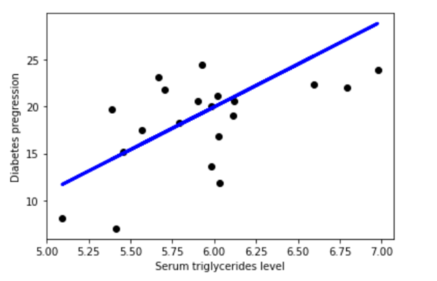

A linear regression model helps in predicting the value of a dependent variable, and it can also help explain how accurate the prediction is. This is denoted by the R-squared and p-value values. The R-squared value indicates how much of the variation in the dependent variable can be explained by the explanatory variable and the p-value explains how reliable that explanation is. The R-squared values range between 0 and 1. A value of 0.8 means that the explanatory variable can explain 80 percent of the variation in the observed values of the dependent variable. A value of 1 means that a perfect prediction can be made, which is rare in practice. A value of 0 means the explanatory variable doesn't help at all in predicting the dependent variable. Using a p-value, you can test whether the explanatory variable's effect on the dependent variable is significantly different from 0.

2)Explain the Anscombe's quartet in detail

**Anscombe’s Quartet**can be defined as a group of four data sets which are **nearly identical in simple descriptive statistics**, but there are some peculiarities in the dataset that **fools the regression model**if built. They have very different distributions and **appear differently**when plotted on scatter plots.

It was constructed in 1973 by statistician **Francis Anscombe** to illustrate the **importance**of **plotting the graphs**before analysing and model building, and the effect of other **observations on statistical properties**. There are these four data set plots which have nearly **same statistical observations**, which provides same statistical information that involves **variance**, and **mean**of all x, y points in all four datasets. This tells us about the importance of visualising the data before applying various algorithms out there to build models out of them which suggests that the data features must be plotted in order to see the distribution of the samples that can help you identify the various anomalies present in the data like outliers, diversity of the data, linear separability of the data, etc. Also, the Linear Regression can be only be considered a fit for the **data with linear relationships**and is incapable of handling any other kind of datasets. These four plots can be defined as follows:

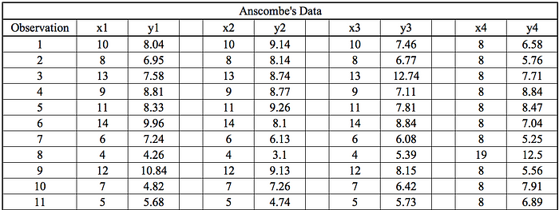

Image by Author

The statistical information for all these four datasets is approximately similar and can be computed as follows:

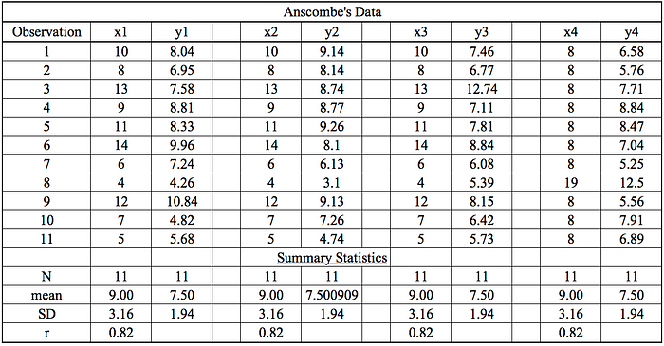

When these models are plotted on a scatter plot, all datasets generate a different kind of plot that is not interpretable by any regression algorithm which is fooled by these peculiarities and can be seen as follows:

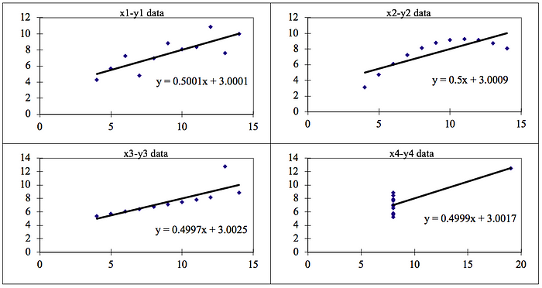

The four datasets can be described as:

1. **Dataset 1:**this **fits**the linear regression model pretty well.
2. **Dataset 2:** this **could not fit**linear regression model on the data quite well as the data is non-linear.
3. **Dataset 3:**shows the **outliers**involved in the dataset which **cannot be handled**by linear regression model
4. **Dataset 4:**shows the **outliers**involved in the dataset which **cannot be handled**by linear regression model

.

3)What is Pearson's R?

Pearson's r is a numerical summary of the strength of the linear association between the variables. If the variables tend to go up and down together, the correlation coefficient will be positive. If the variables tend to go up and down in opposition with low values of one variable associated with high values of the other, the correlation coefficient will be negative. "Tends to" means the association holds "on average", not for any arbitrary pair of observations, as the following scatterplot of weight against height for a sample of older women shows. The correlation coefficient is positive and height and weight tend to go up and down together. Yet, it is easy to find pairs of people where the taller individual weighs less, as the points in the two boxes illustrates.

The Pearson's correlation coefficient varies between -1 and +1 where:

r = 1 means the data is perfectly linear with a positive slope (i.e., both variables tend to change in the same direction)

r -1 means the data is perfectly linear with a negative slope (i.e., both variables tend to change in different directions)

r = O means there is no linear association

r > O < 5 means there is a weak association

r > 5 < 8 means there is a moderate association

r > 8 means there is a strong association

4) What is scaling? Why is scaling performed? What is the difference between normalized scaling and standardized scaling?

Scaling is a step of data Pre-Processing which is applied to independent variables to normalize the data within a particular range. It also helps in speeding up the calculations in an algorithm.

Most of the times, collected data set contains features highly varying in magnitudes, units and range. If scaling is not done then algorithm only takes magnitude in account and not units hence incorrect modelling. To solve this issue, we have to do scaling to bring all the variables to the same level of magnitude. It is important to note that scaling just affects the coefficients and none of the other parameters like t-statistic, F-statistic, p-values, R-squared, etc.

1- Normalization/Min-Max Scaling:

It brings all of the data in the range of 0 and 1. sklearn.preprocessing.MinMaxScaler helps to implement normalization in python.

2- Standardization Scaling:

Standardization replaces the values by their Z scores. It brings all of the data into a standard normal distribution which has mean (u) zero and standard deviation one (o).

sklearn.preprocessing.scale helps to implement standardization in python.

One disadvantage of normalization over standardization is that it loses some information in the data, especially about outliers.

5)You might have observed that sometimes the value of VIF is infinite. Why does this happen?

The variance inflation factor (VIF) quantifies the extent of correlation between one predictor and the other predictors in a model. It is used for diagnosing collinearity/multicollinearity. Higher values signify that it is difficult to impossible to assess accurately the contribution of predictors to a model.

VIF = 1/1-RA2

If there is perfect correlation, then VIF = infinity. A large value of VIF indicates that there is a correlation between the variables. If the VIF is 4, this means that the variance of the model coefficient is inflated by a factor of 4 due to the presence of multicollinearity. This would mean that that standard error of this coefficient is inflated by a factor of 2 . The standard error of the coefficient determines the confidence interval of the model coefficients. If the standard error is large, then the confidence intervals may be large, and the model coefficient may come out to be non-significant due to the presence of multicollinearity.

6) What is a Q-Q plot? Explain the use and importance of a Q-Q plot in linear regression.

Q Q Plots (Quantile-Quantile plots) are plots of two quantiles against each other. A quantile is a fraction where certain values fall below that quantile. For example, the median is a quantile where 50% of the data fall below that point and 50% lie above it. The purpose of Q Q plots is to find out if two sets of data come from the same distribution. A 45-degree angle is plotted on the Q Q plot; if the two data sets come from a common distribution, the points will fall on that reference line.

The quantile-quantile (q-q) plot is a graphical technique for determining if two data sets come from populations with a common distribution. A q-q plot is a plot of the quantiles of the first data set against the quantiles of the second data set. The slope tells us whether the steps in our data are too big or too small.

For example, if we have N observations, then each step traverses I/(N-I) of the data. So, we are seeing how the step sizes (a.k.a. quantiles) compare between our data and the normal distribution.

A steeply sloping section of the QQ plot means that in this part of our data, the observations are more spread out than we would expect them to be if they were normally distributed. One example cause of this would be an unusually large number of outliers (like in the QQ plot we drew with our code previously).